Project by : 9guest@engineeringgood.org

my project (1st version). EG CAC App
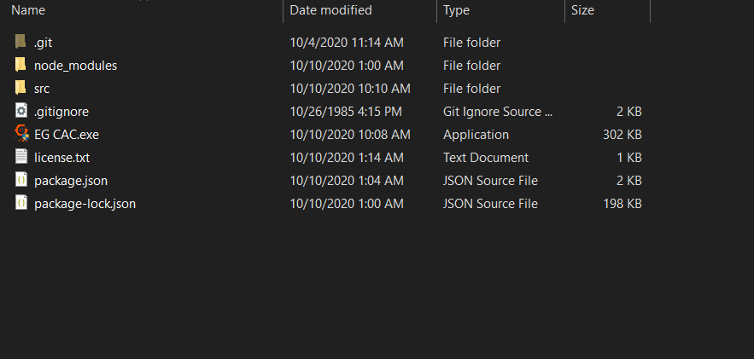

This App is built with Electron.js. I have used multiple coding languages to complete this project which are HTML, JS, Powershell, Batch(CMD).

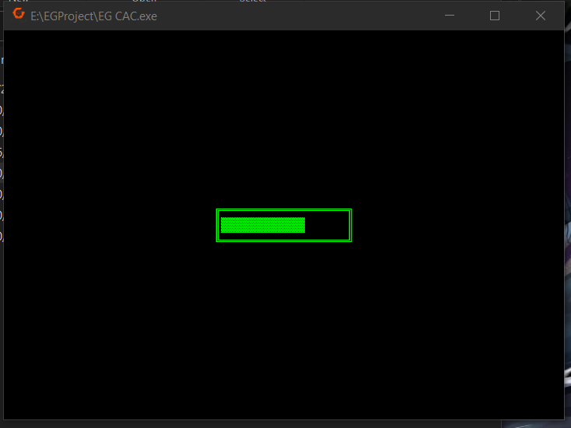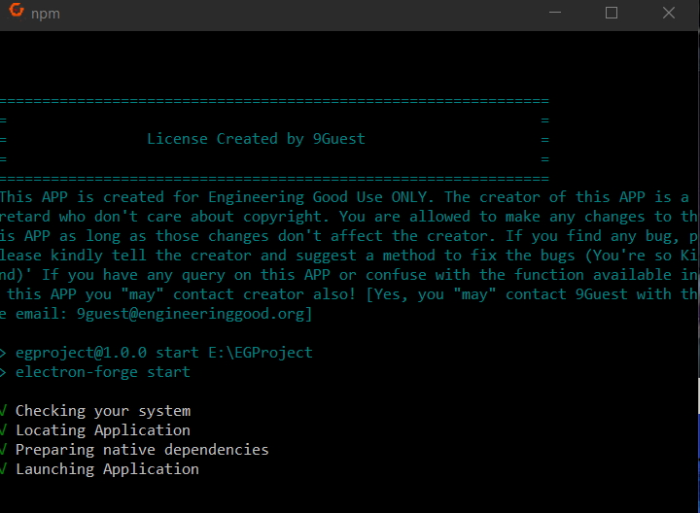

As shown above, when running “EG CAC.exe” , a batch file (CMD) will show up and run process to start the App.


Next, a window will pop out for user to carry out the functions
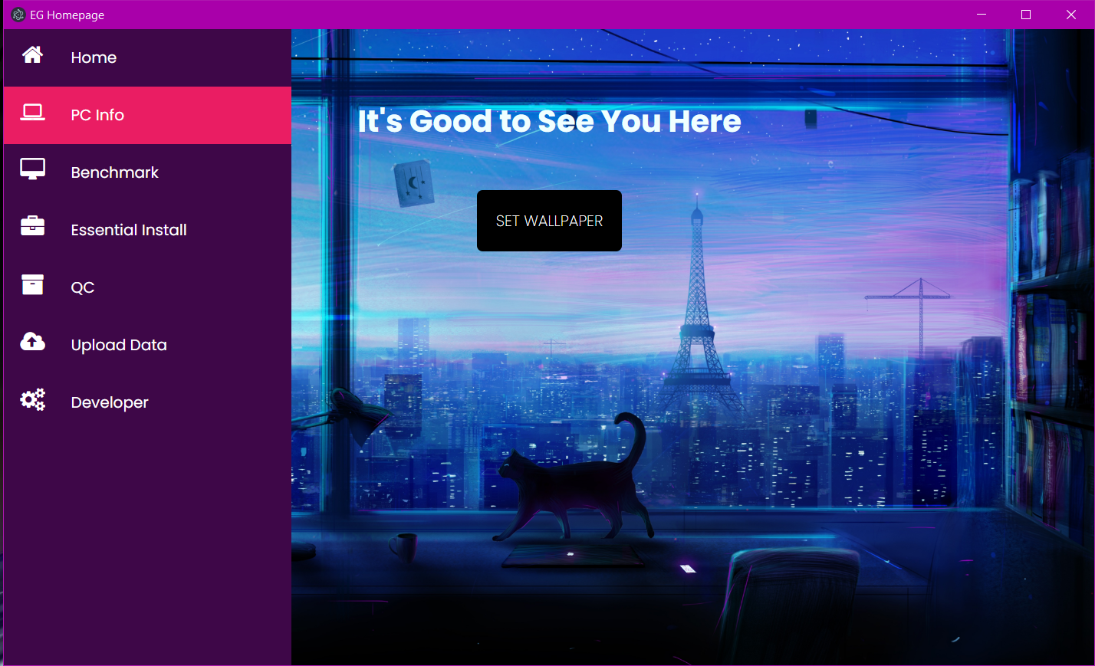

As shown from above image, there are different sections at the navbar where users can click in and carry out functions.

“PC Info” is used to check some essential information of the PC with Javascript or Powershell

“Benchmark” is used to run PC Mark 10 to check the essential and productivity scores of the PC to determine whether the PC can run

“Essential Install” is used to install essential software like Google Chrome, Zoom, LibreOffice and Adobe Reader to the PC for working or study purpose.

“QC” is used to check whether the software is successfully installed and check the internet connection of the PC.

“Upload Data” is used to upload the information of the PC like some PC info, PC registry number, Benchmark Scores, etc. to the Google Sheets.

“Developer” is just telling users where to contact me for bugs or queries.

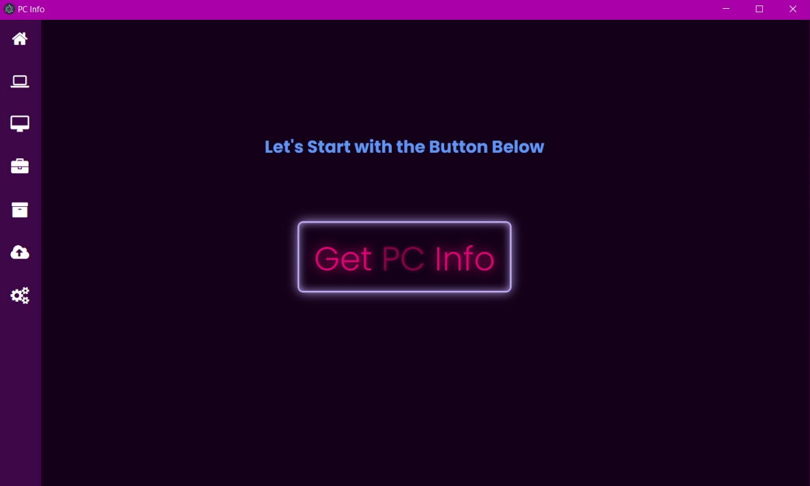

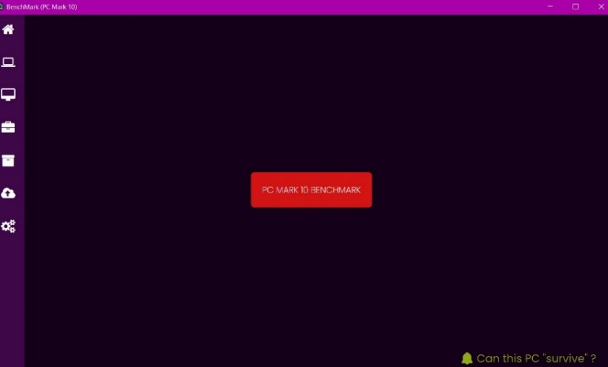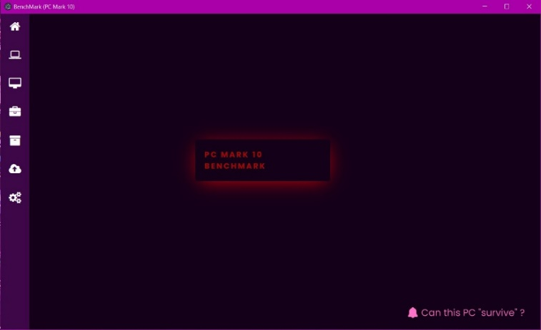

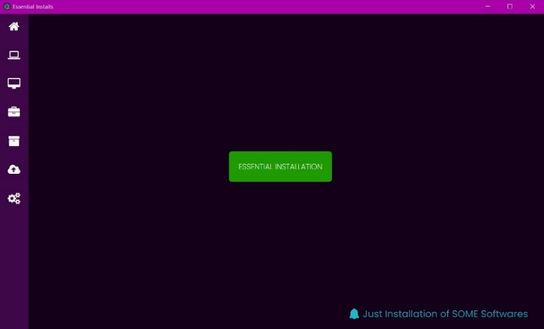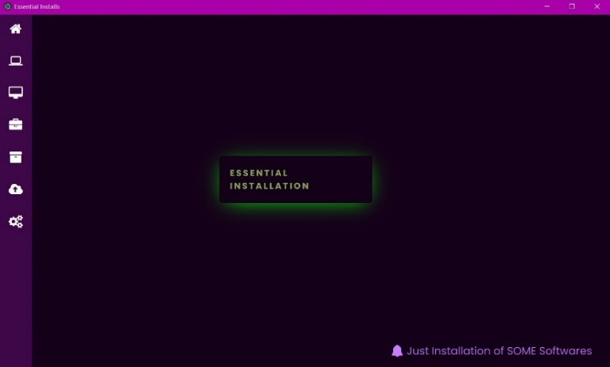
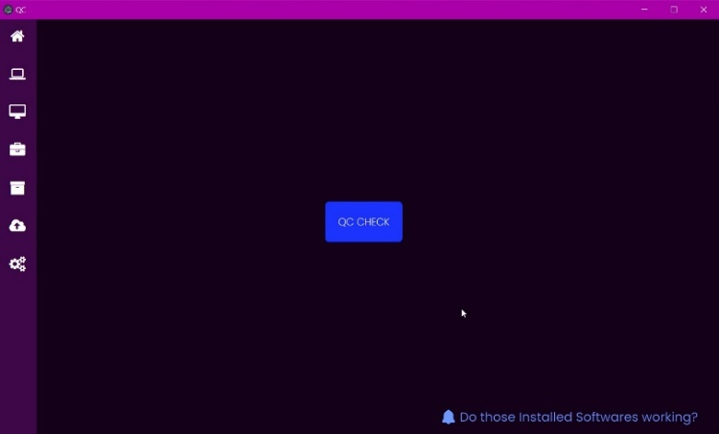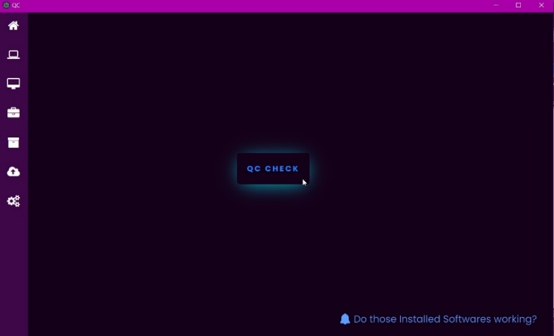

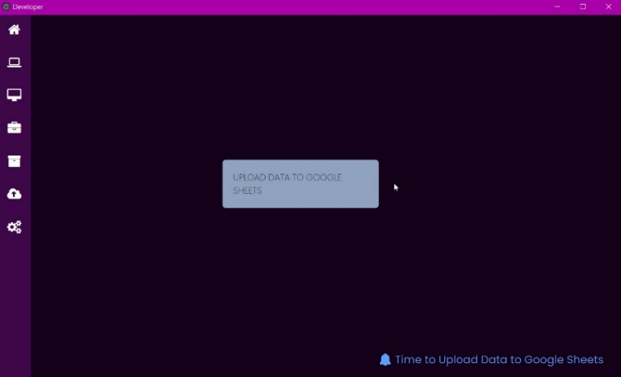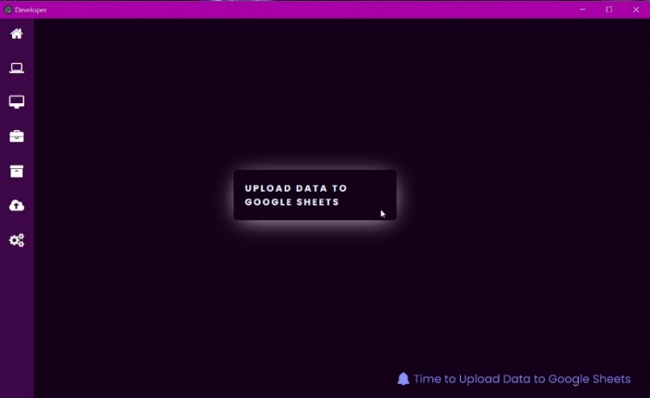

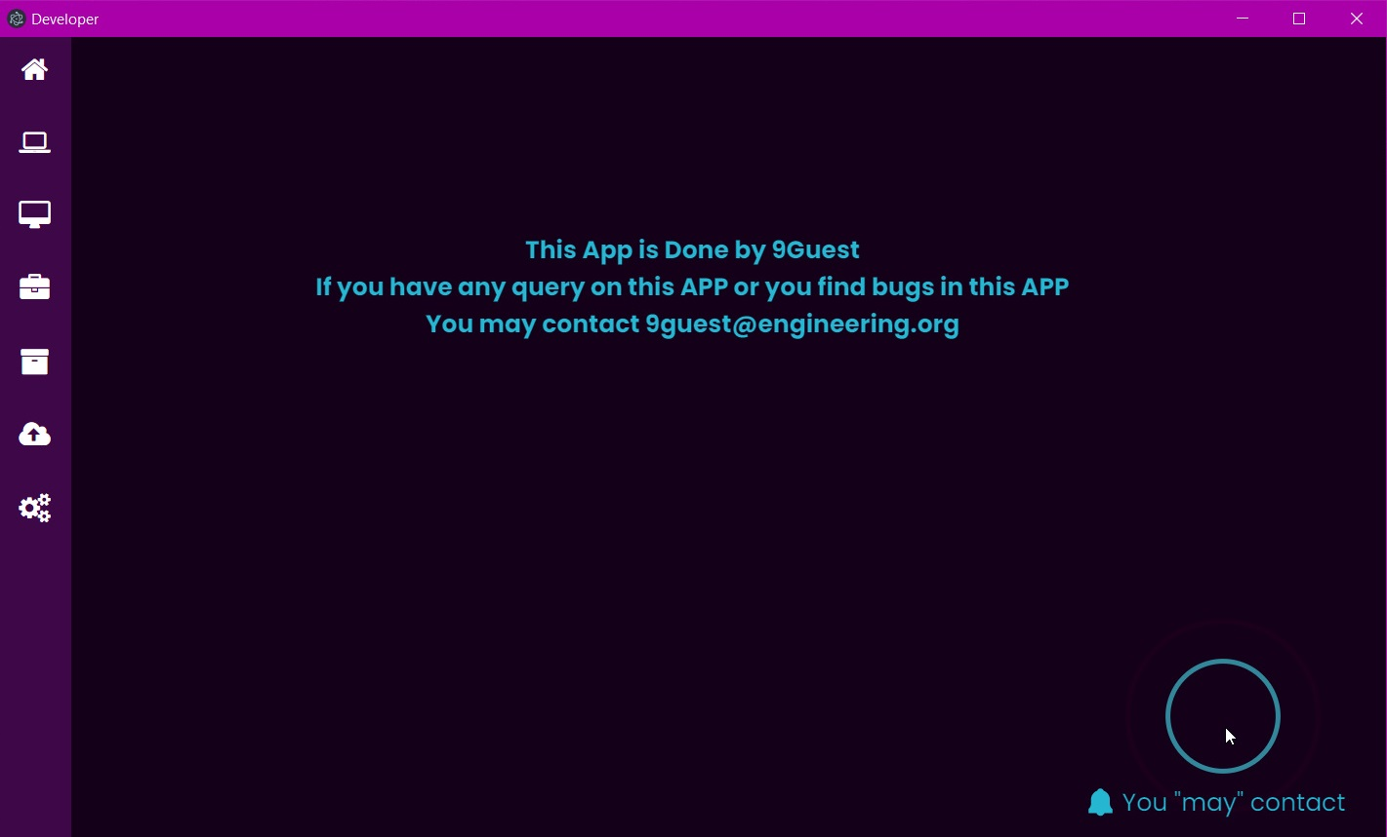

Those are the Slides users may see from the App.

The front-end of the App (Slides shown above) is designed and created with HTML, CSS.

The back-end of the App (background functions) is created with JavaScript, Powershell and Batch (CMD).
Explain on How the App works:
- I am use electron.js as the template to build this App
- Electron.js offers HTML-type front-design which works like website
- To start the App, it uses “index.js” which is in JavaScript to create a window (Chromium) and display the App
- All the functions running behind the App is carried out by JS script
- Due to limitation of my JS knowledge, I am unable to retrieve the PC info and PC processes through Javascript / Electron.js. Therefore, I am using JavaScript functions to call or start Batch file to run PowerShell Script just as how we do before (run ???.bat to call ???.ps1)
- Clicking Buttons on different pages of my App will “summons” the PowerShell windows and processes will be run.
- Due to some unsolved problems by the Electron.js, I am calling the form from GitHub-host static website for Google Sheets Data Entries.
- The whole App is basically just giving the users a better appearance when running different PowerShell Script and taking down info without using paper resource.
- I am sure there are many things in my App can be improved. The “skeleton” of this project has been done. We need Pros to improve and beautify the project.

What are the benefit(s) for using this App ?

As I said in previous reports, we already have solutions to complete all the functions I have in the App. Engineering Good originally runs Powershell script directly from batch or command prompt (CMD) and we have to write down the PC info on a CAC paper.

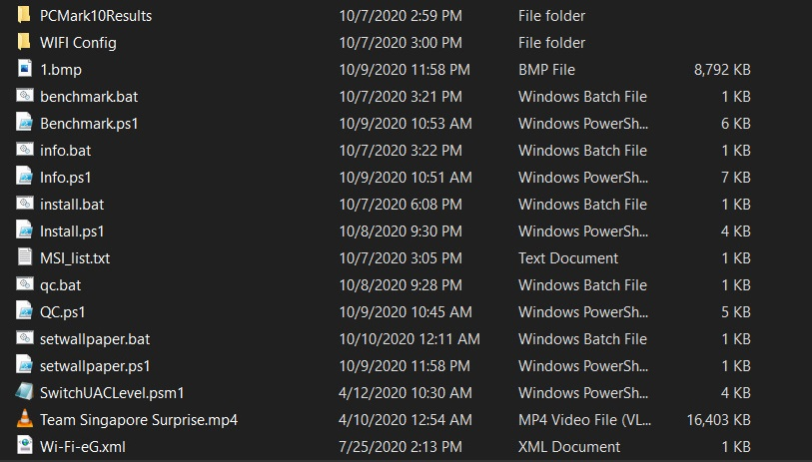
Previously, we have to find out the correct batch script to run the correct Powershell Script for different functions like finding PC info, getting software to be installed and install PC Mark 10 to get essential and productivity scores of the PC.

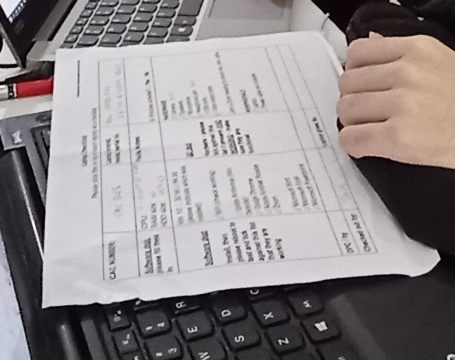
This the CAC paper where we write all the info of the PC in.
This could be a waste of resources.

By using the App, we could save time on searching correct Powershell script and data input through Google Sheets can save paper resource. And my App has a better appearance than looking at the list of the Powershell and Batch script.

Problem on data auto-entry:
There is one of the problems in this App which is I can get data imported from PowerShell Variables to JavaScript. Maybe there is a way to do so, but I can’t find a solution to that (Pros may edit the project to fix this). As told, PowerShell can auto import the data to Google Sheets, so that users may not to manually enter so many data to the form by their own hands. The PowerShell can just directly imported to the App by changing the back-end JavaScript function, “formexec();”, to run on the PowerShell Script instead of opening the webpage for Google Sheets data entries.

